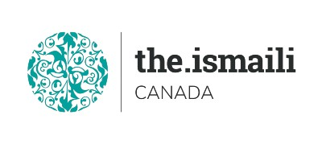
Microsoft Access (Database) Basic

November 30, December 01-02, Tuesday, Wednesday, Thursday
5:00 PM-7:00 PM BC, 6:00 PM-8:00 PM Alberta, 8:00 PM - 10:00 PM Eastern Time
On Line Via Zoom (Link will be sent to registered participants)
Fee for this three evenings information session is $10.00

Participants will acquire basic knowledge on how to effectively use Microsoft Access
Course Outline
- First look at Microsoft Access  - Understand the ribbon and contextual tabs  - Using and modifying tabs and view  - Create and open an Access database  Database concepts  - Basic and relational database  - Tables, records, fields keys and indexes  - Access tables  - Create and save a table  - Add, delete fields and data and records  - Apply rules to relationships  - Define printing feature and options | - Access forms and queries  - Create open save delete and close Forms  - Create & save a single/multiple table query  - Apply filters, edit, run and delete a query  - Sorting records  - Access reports  - Create and save a report,  - Grouping data under a specific field

Video Recordings link of this Class will be sent to all attendees who join live session only.

Free Online Classes

https://edu.gcfglobal.org/en/access2016/

Advanced registration with Pre-Payment Required
https://iicanada.org/form/introduction-microsoft-access-basic-0

For more information and to register E-mail: epb.crcprairies@iicanada.net

Phone or Text: Zull Punjani 403-689-8584 or EPB Prairies Office: Message # (403) 215-6200 Ext. 7039

**Please visit https://www.iicanada.org/ for more information**

