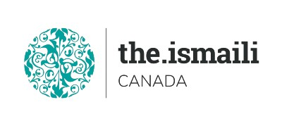
Introduction to Microsoft Project Basic
Sunday October 03, 2021

9:00 AM-2:00 PM BC, 10:00 AM-03:00 PM Alberta, 12:00 Noon-05:00 PM Eastern Time
On Line Via Zoom (Link will be sent to registered participants)
Fee for this Full Day Information Session is $10.00

Participants will acquire basic knowledge on how to effectively use Microsoft Project
Course Outline

Understanding Project Management  - Project Planning  - Managing Schedules  - Using Resources  - Tracking Time  - Providing Project Status Reports  Getting Started with Project  - Navigating the Project Environment  - Creating and Saving a Project  - Defining a Project  Understanding Task Dependencies  - Successor Tasks  - Predecessor Tasks  - What are the Different Dependencies?  - What is Lag Time?  - What is Lead Time?  - What are Milestones | MS Project Views  - Gantt View  - Task View  - Resource Sheet View  Entering and Working with Data  - Entering Schedule Data  - Assigning Resources to Tasks  - Resource Levelling  - Working with a Critical Path  - Reporting

Free Online resources

https://www.youtube.com/watch?v=5v_42_4Vl2o

Advanced Registration with Pre-Payment Required
https://iicanada.org/form/introduction-microsoft-project (Oct 3)

For more information and to register E-mail: epb.crcprairies@iicanada.net

Phone or Text: Zull Punjani 403-689-8584 or EPB office Message # (403) 215-6200 Ext. 7039

**Please visit the digital Al-Akbhar for more information**

