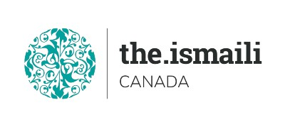
Microsoft Word Basic

Sunday August 08, 2021
9:00 AM-2:00 PM Pacific, 10:00 AM-3:00 PM MST, 12:00 Noon-5:00 PM Eastern Time
On Line Via Zoom (Link will be sent to registered participants)
Fee for One Day Information Session is $10.00
Participants will acquire basic knowledge on how to effectively use Microsoft Word
Course Outline
New Microsoft Word Interface  - Quick access ribbon toolbar  - Advanced tabs and customization of ribbon  Getting Started with Word  - Identify the Components of the Word Interface  - Help  - Editing a Document  - Navigate and Select Text  - Modify Text  - Find and Replace Text  Understanding and working with documents  - Creating and saving documents  - Creating headers and footers  Formatting Text and Paragraphs  - Apply Character Formatting  - Align Text Using Tabs  - Display Text as List Items  - Apply Borders and Shading  - Apply Styles  Adding Tables  - Insert, Modify, Format a Table and Convert Text to a Table | Managing List  - Sort and Renumber a List  - Insert Graphic Objects  - Insert Symbols and Special Characters  Controlling Page Appearance  - Apply a Page Border and Color  - Add a Watermark  - Add Headers and Footers  - Control Page Layout  Proofing a Document  - Check Spelling and Grammar  - Other Proofing Tools  Templates  - Creating and Using a Template  Working with Styles  - Creating, Applying, and Modifying  Styles  - Using Building Blocks and Quick Parts  - Inserting Quick Parts  - Using the Building Blocks Organizer  - Saving Quick Parts

Free Basic Computer Classes

https://edu.gcfglobal.org/en/word2016/

Advanced Registration with Pre-Payment Required
https://iicanada.org/form/introduction-microsoft-word-basic (Aug 08)

For more information and to register E-mail: epb.crcprairies@iicanada.net

Phone or Text: Zull Punjani 403-689-8584 or EPB office Message # (403) 215-6200 Ext. 7039

**Please visit the digital Al-Akbhar for more information**

