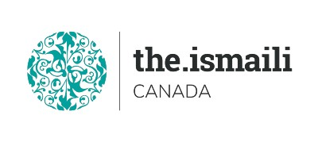
Microsoft Word Intermediate
August 10-12-14: Tuesday – Thursday - Saturday
5:00 PM-7:00 PM BC, 06:00 PM-08:00 PM Alberta, 08:00 PM-10:00 PM Eastern Time
On Line Via Zoom (Link will be sent to registered participants)
Fee for this three evenings Information Session is $10.00
Participants will acquire Intermediate knowledge on how to effectively use Microsoft WORD
New Microsoft Word Interface  - Quick access ribbon toolbar  - Advanced tabs and customization of ribbon  Working with Text  - Indents and Tabs  - Line and Paragraph Spacing  - Lists  - Sort and Renumber a List  - Hyperlinks  Working with Pages and Paragraphs  - Headers, Footers and Page Numbers  - Page Borders  - Watermarks  - Page Layout  Working with Tables  - Creating Tables  - Formatting Tables | Adding Charts  Creating Charts  Formatting Charts  Proofing Documents  Spelling and Grammar  Working with Objects  Adding Pictures  Adding Shapes and SmartArt  Modifying Objects  Performing a Mail Merge  Using the Wizard  Select Source Document  Select Recipients  Preview the Document  Complete the Merge  Printing Documents  Proofing and Printing the Document
Course Outline

Pre-Requirement for this course: Basic Knowledge of Microsoft Word

Please learn Microsoft Word Basic on line free class at

https://edu.gcfglobal.org/en/word2016/

Advanced Registration with Pre-Payment Required

For more information and to register E-mail: epb.crcprairies@iicanada.net

Phone or Text: Zull Punjani 403-689-8584 or EPB office Message # (403) 215-6200 Ext. 7039

**Please visit the digital Al-Akbhar for more information**

