Short-term COVID-19 financial tips for Coronavirus
If you want to protect your finances in the midst of this alarming pandemic, break your goals out into long and short-term goals.
This can help give a better view of your most pressing concerns.
The coronavirus has already had far-reaching effects on the global economy and our stock market. But even if you’re not invested in domestic and foreign markets, there are financial concerns much closer to home that this global pandemic can cause.
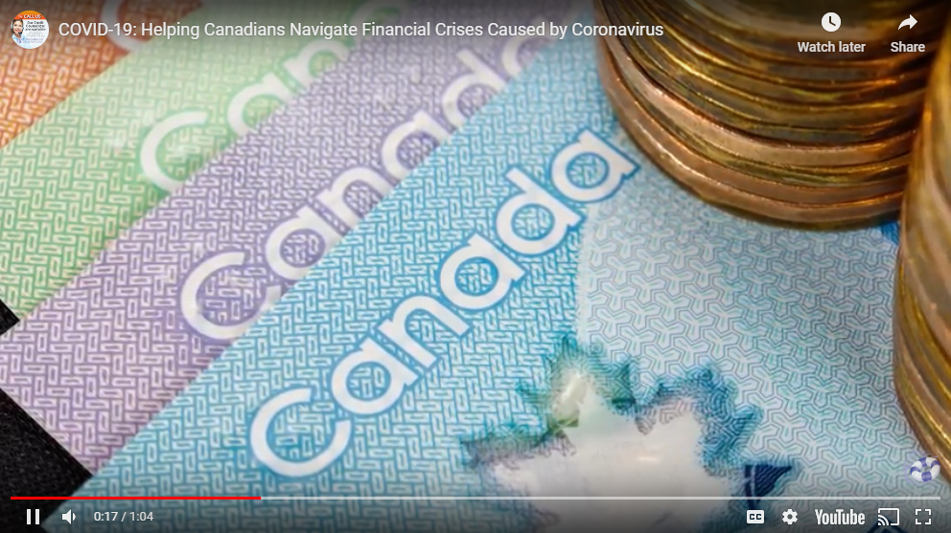
The tips below can help you keep your finances in working order during the Covid-19 crisis.
If Covid-19 financial pressure is mounting, call your creditors and lenders
- Get ahead of the issue by making a call and explaining the situation
- Remaining behind on payments without reaching out can be detrimental to your credit

Do not engage in panic purchasing
You may have seen footage of shoppers clearing grocers of their food and cleaning supplies.
- Buy what you need but not more
- Ask yourself if this purchase is essential; “Do I really need this much toilet paper?”

If you’re stuck at home, take some of your time to build financial literacy
- Follow the FCAC’s guidelines and consider how you can save money during this time of uncertainty.
- Calculate your credit card payments or other expenses to see where you are.
- Read financial blogs and review your budget.

Long-term financial tips
The long-term economic effects of COVID-19 financial implications can be far-reaching. It may even trigger another global recession. With that in mind, it’s important to shore up your finances against long-term economic instability.

Reduce expenses to increase savings and avoid new credit card debt
- What subscriptions can you cancel immediately to save money?
- What tactics can you employ to conserve:
  - Water
  - Energy
  - Food
- Cancel trips and non-essential travel

Focus on paying off the debt you already have
- Stay current with your payments and pay on time
- Know how much you have at all times
- Set up automatic payments

Expand your emergency savings fund
- Social distancing may come into play, so seek out remote opportunities if you can
- Reallocate funds from nonessential categories to bolster your emergency fund

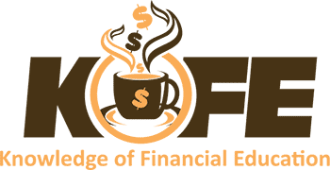
A product of
Toll free number (844) 329-3834
English-French-Farsi-Dari-Arabic
Private & Confidential
KOFE is a web‐based financial education centre, set up exclusively for our Jamat through Consolidated Credit Counselling Services of Canada, a national accredited non‐profit organization.
Ask a Financial Coach (English-French-Farsi-Dari-Arabic)
- For tailored solutions to get out of debt
- Am I ready to purchase a home?
- How do I make a budget?
- Get answers to your financial questions
- Private & Confidential
Contact your qualified financial coach today for free. Register today with KOFE (only username & e-mail required) to access all the free services, various tools and calculators, a variety of educational resources like interactive courses, informative videos, publications and webinars to help you build a strong financial future. Toll free number (844) 329-3834
What is KOFE? See video

